© Engineered Science Publisher LLC 2022
Lignin/Si hybrid carbon nanofibers towards highly efficient sustainable Li-ion anode materials

Mario Culebras^{1,4}, Gearoid A. Collins², Anne Beaucamp¹, Hugh Geaney², and Maurice N. Collins^{1,3}
¹Stokes Laboratories, Bernal Institute, University of Limerick, Ireland.
²Bernal Institute & Chemical Sciences Department, University of Limerick, Ireland.
³Advanced Materials and Bioengineering Research (AMBER) Centre, Ireland.
⁴Institute of Material Science of the University of Valencia, Spain

* E-mail: Maurice.collins@ul.ie

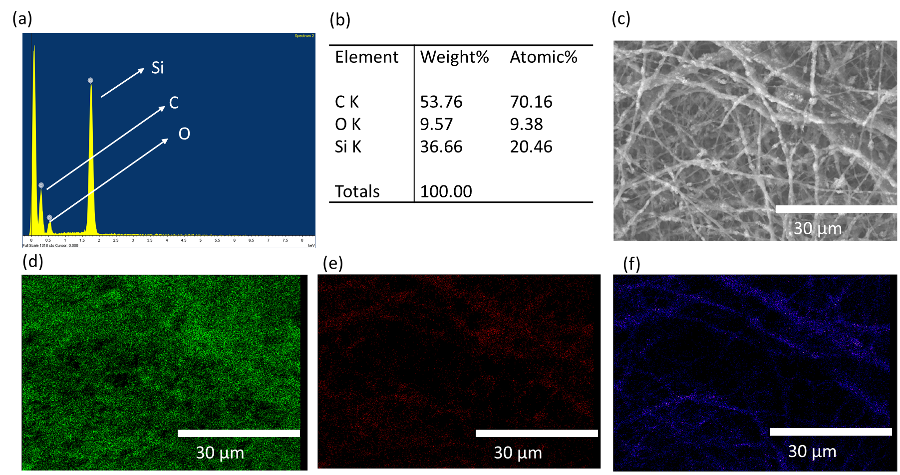
Figure S1. EDS spectrum (a), microanalysis (b) and mapping of CNF/Si_15 sample. SEM (c), Si (d), O (e) and C (f).

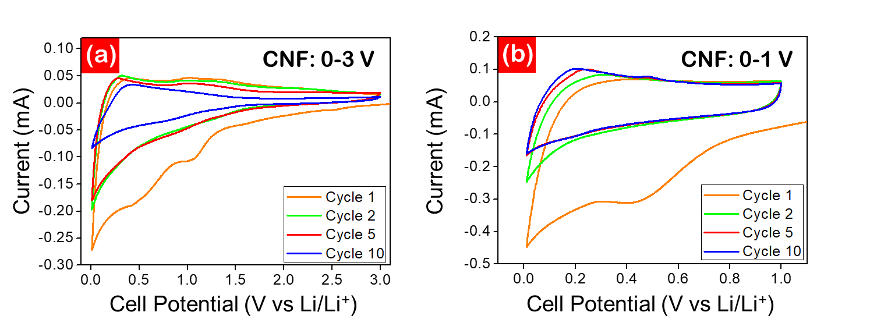

Figure S2. 1st (orange), 2nd (green), 5th (red) and 10th cycle (blue) CVs of CNF between (a) 0.01-3.0 V vs Li/Li⁺ and (b) 0.01-1.0 V vs Li/Li⁺. CVs were recorded at a scan rate of 0.05 mV s⁻¹.

Figure S2 illustrates the operating potential window for CNF. Although CNF is electrochemically active over the entire 0.01-3.0 V vs Li/Li⁺ range (Fig. S2a), the majority of capacity is delivered within a 0.01-1.0 V vs Li/Li⁺ potential window (Fig. S2b).

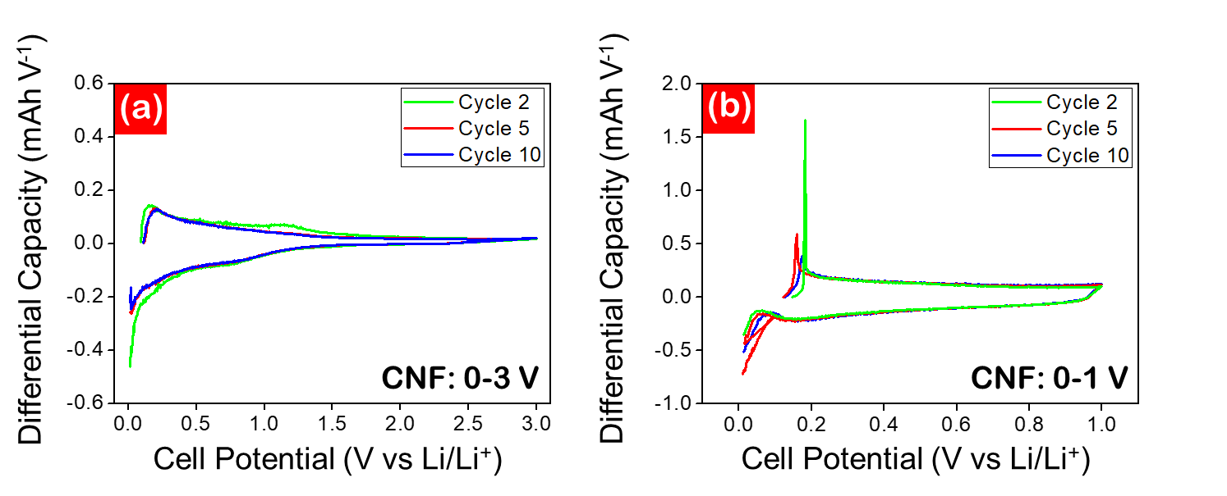
Figure S3. 2nd (green), 5th (red) and 10th cycle (blue) DCPs of CNF between (a) 0.01-3.0 V vs Li/Li⁺ and (b) 0.01-1.0 V vs Li/Li⁺. Cells were cycled at a constant current density of 100 mA g⁻¹.

DCPs of CNF similarly reflect this behaviour, showing that CNF is electrochemically active as high as 3.0 V vs Li/Li⁺ (Fig. S3b), but the majority of capacity is achieved within a tighter 0.01-1.0 V vs Li/Li⁺ potential window (Fig. S3b), showing promise for translation to energy-dense full-cell analogues.
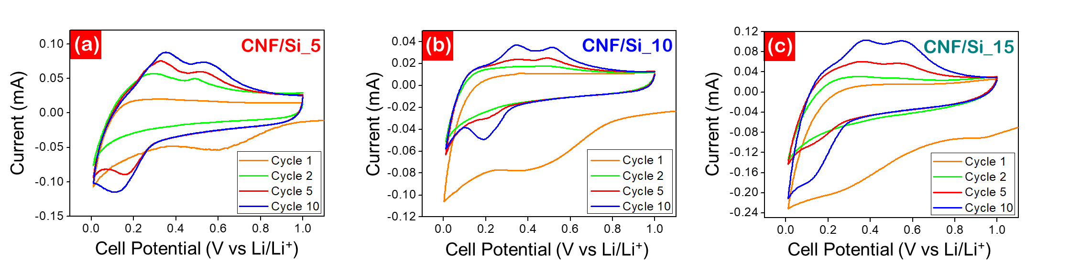
Figure S4. 1st (orange), 2nd (green), 5th (red) and 10th cycle (blue) CVs of (a) CNF/Si_5, (b) CNF/Si_10 and (c) CNF/Si_15. CVs were recorded at a scan rate of 0.05 mV s⁻¹ between 0.01-1.0 V vs Li/Li⁺.

CNF/Si_5 (Fig. S4a), CNF/Si_10 (Fig. S4b) and CNF/Si_15 (Fig. S4c) exhibit similar CV profiles with the two-step redox of Li-Si alloying gradually activated over the first 10 cycles of each cell.

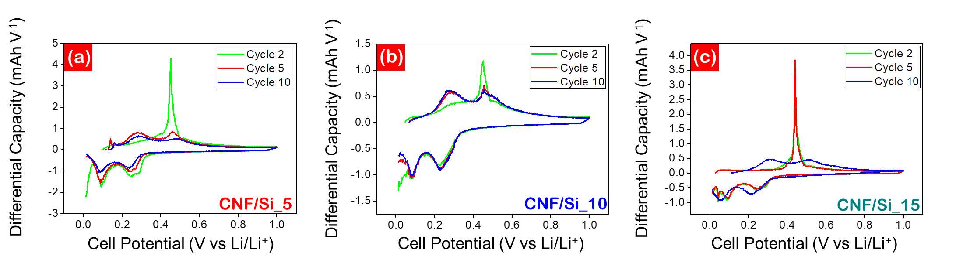
Figure S5. 2nd (green), 5th (red) and 10th cycle (blue) DCPs of (a) CNF/Si_5, (b) CNF/Si_10 and (c) CNF/Si_15. Cells were cycled at a constant current density of 100 mA g⁻¹ between 0.01-1.0 V vs Li/Li⁺.

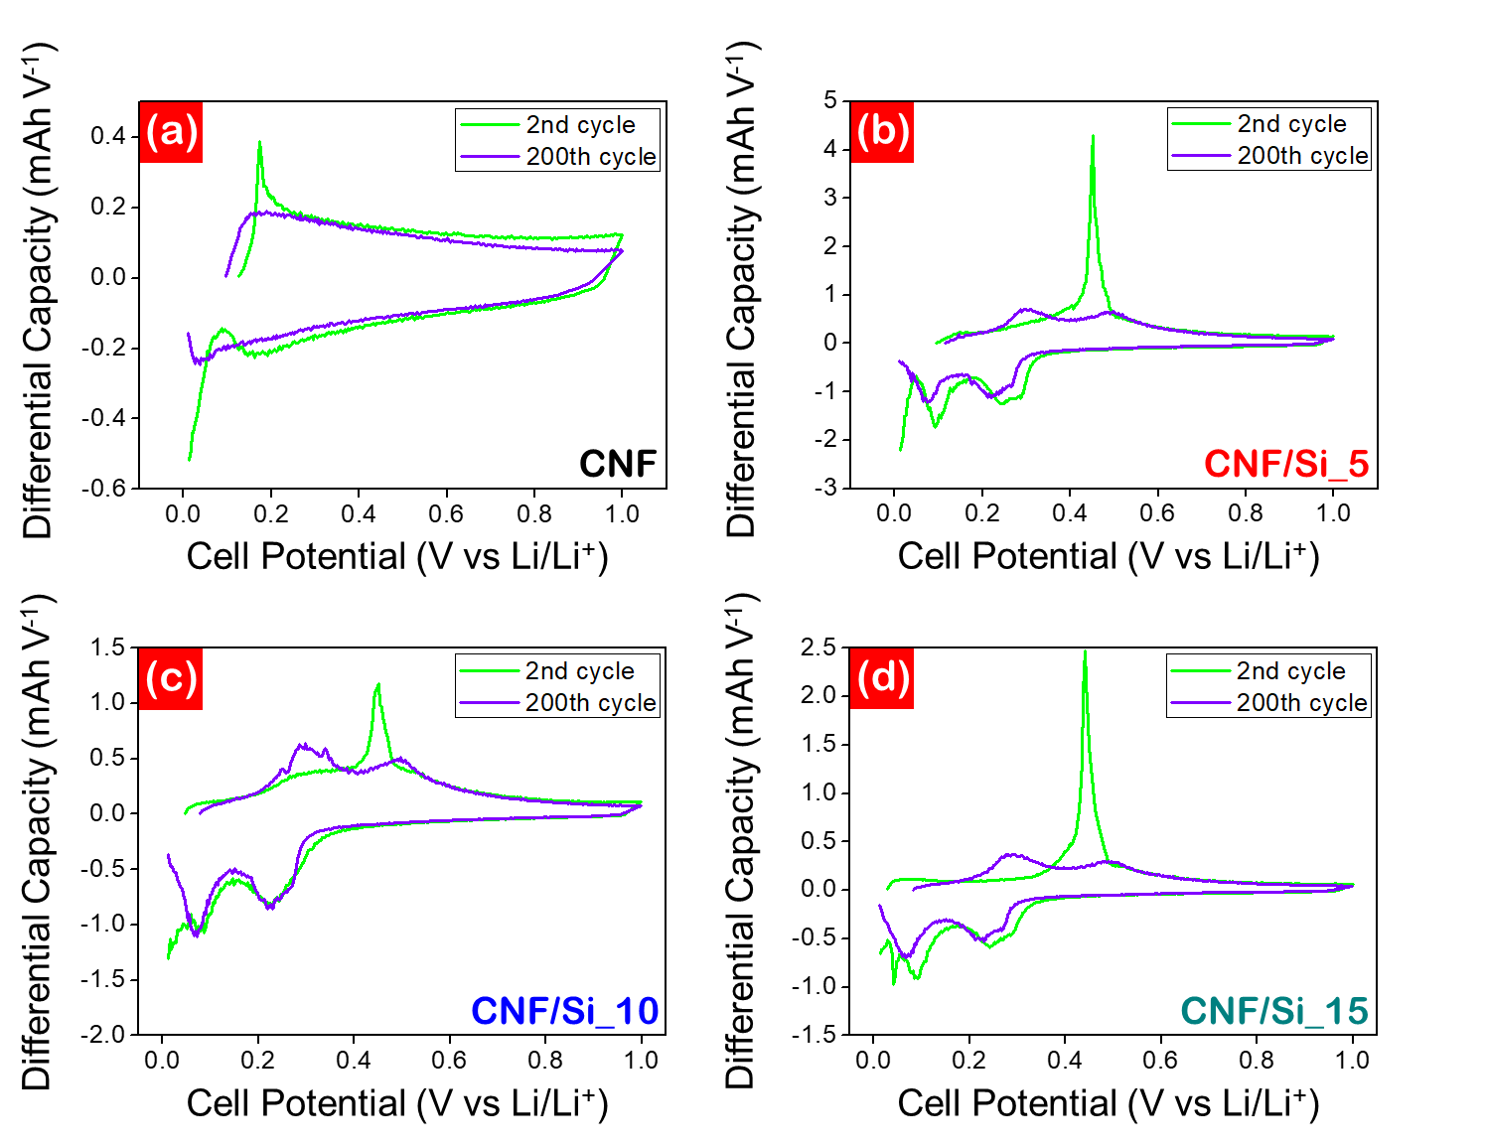
Figure S6. Evolution of DCPs for (a) CNF, (b) CNF/Si_5, (c) CNF/Si_10 and (d) CNF/Si_15 from the 2nd to the 200th cycle. Cells were cycled at a constant current density of 100 mA g⁻¹ between 0.01-1.0 V vs Li/Li⁺.

The excellent long-term stability of CNF is reflected by the stability of the DCP plots showing minimal drop in peak intensity and no notable potential shifting over 200 cycles (Fig. S6a). Slight peak shifting is observed for CNF/Si_5 (Fig. S6b), CNF/Si_10 (Fig. S6c) and CNF/Si_15 (Fig. S6d), indicative of an increased cell impedance over cycle life.

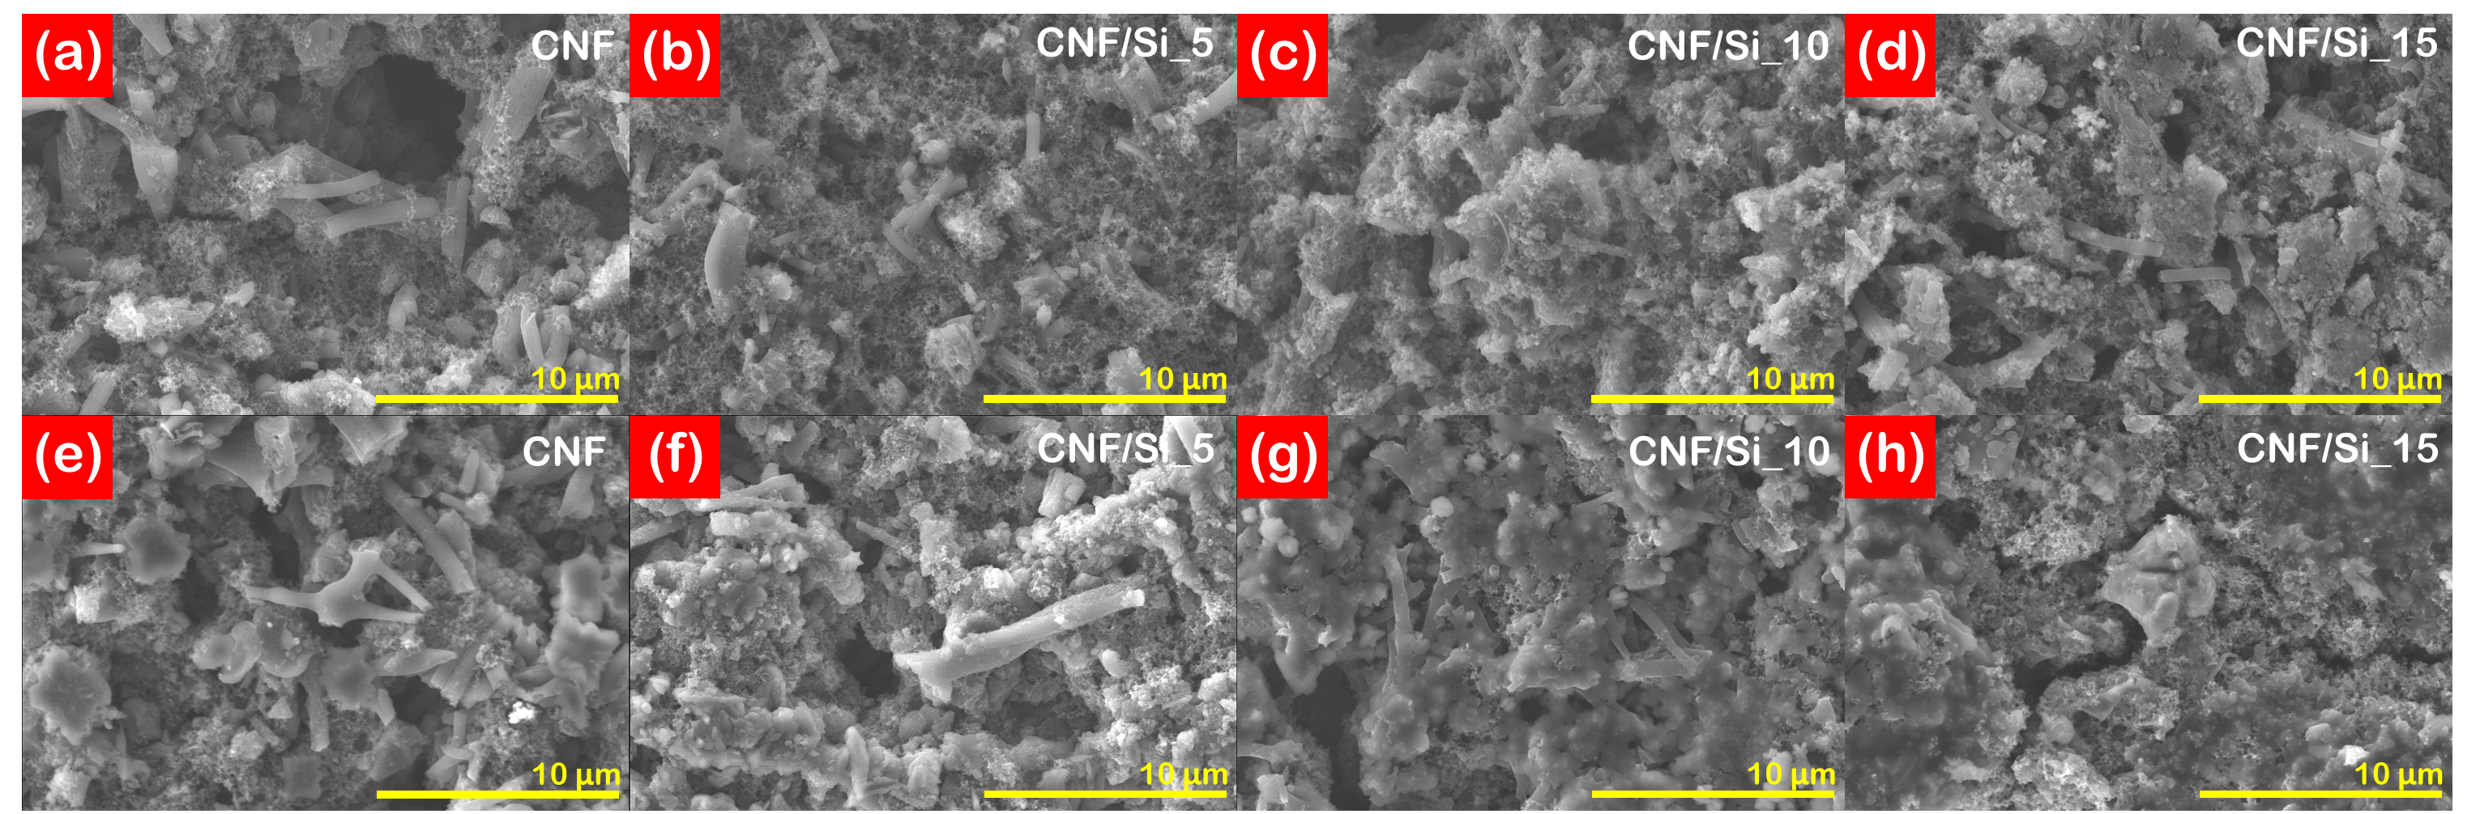
Figure S7. SEM of (a-d) pristine and (e-h) post-cycled CNF, CNF/Si_5, CNF/Si_10 and CNF/Si_15 Anodes were cycled for 200 cycles at 100 mA g⁻¹.

